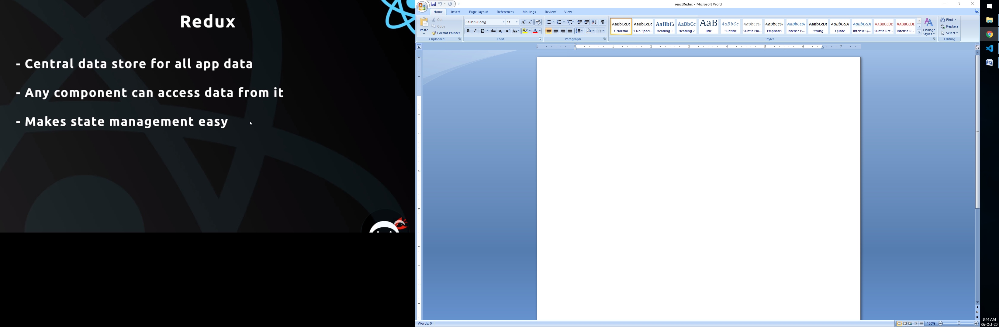

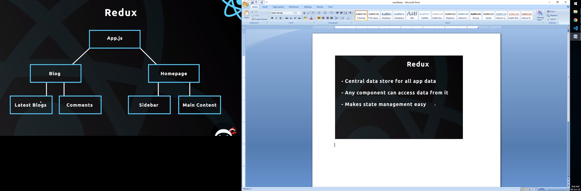

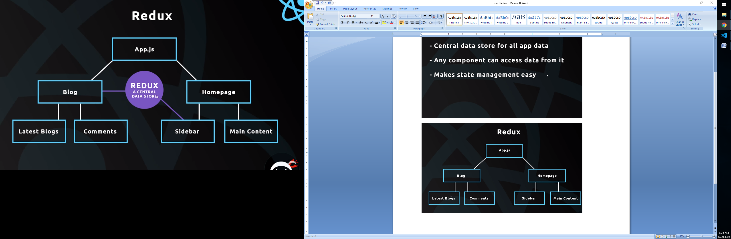

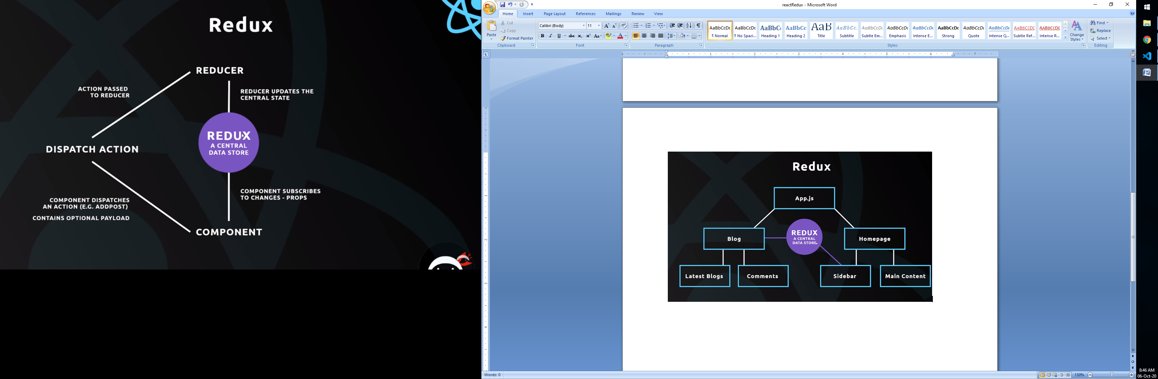

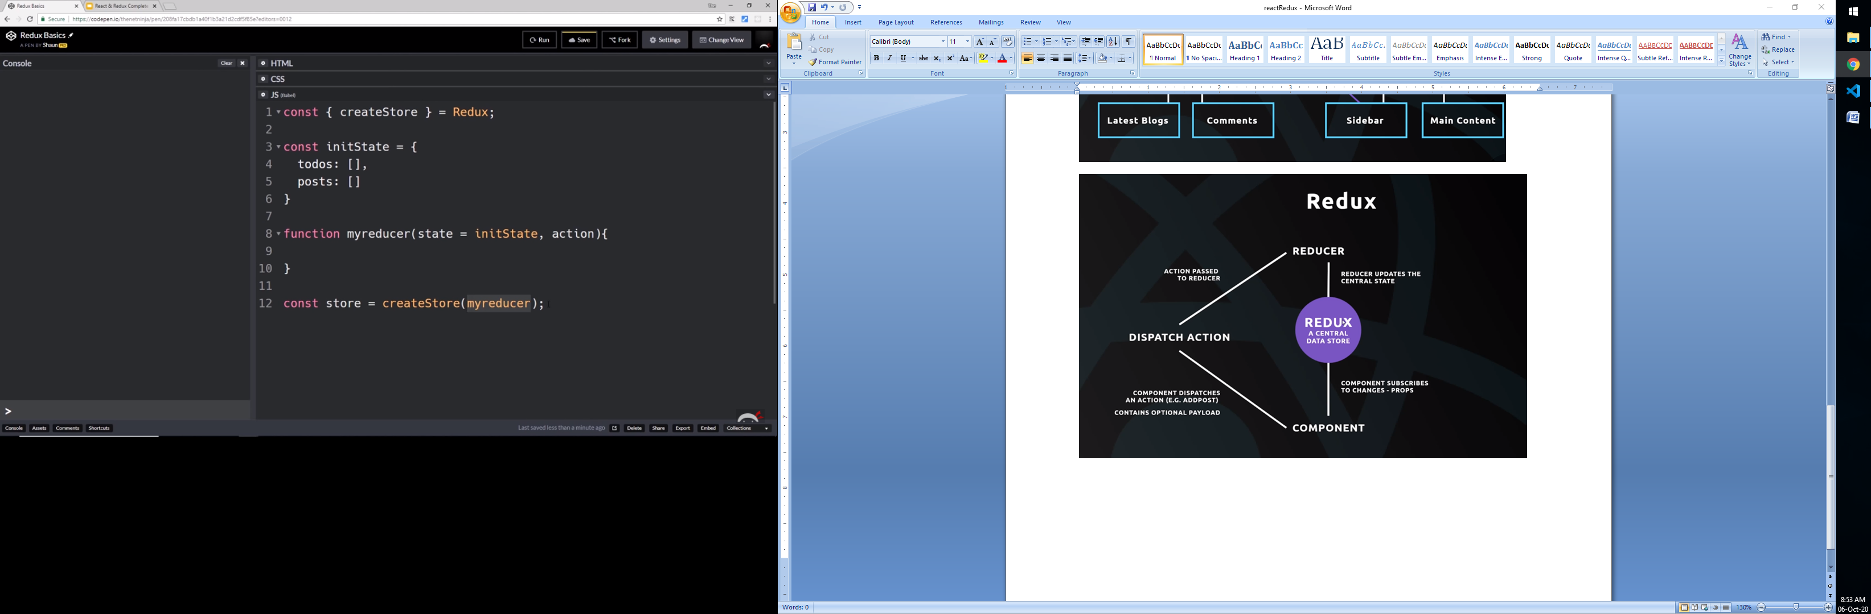

Dispatch action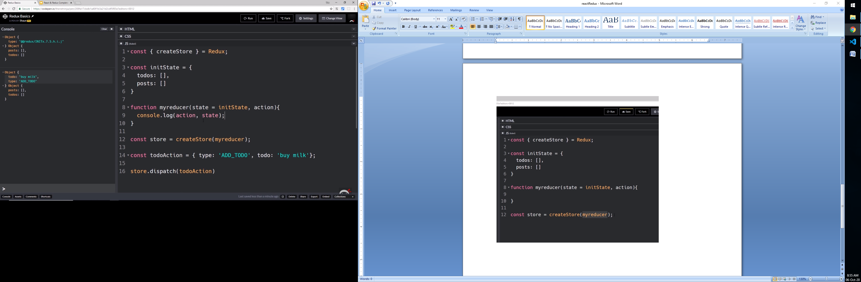

Update state

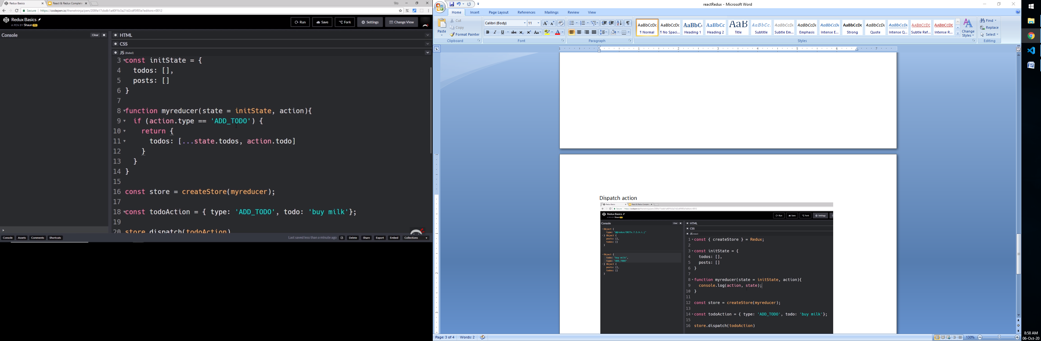

Subscribe store (to detect state change)

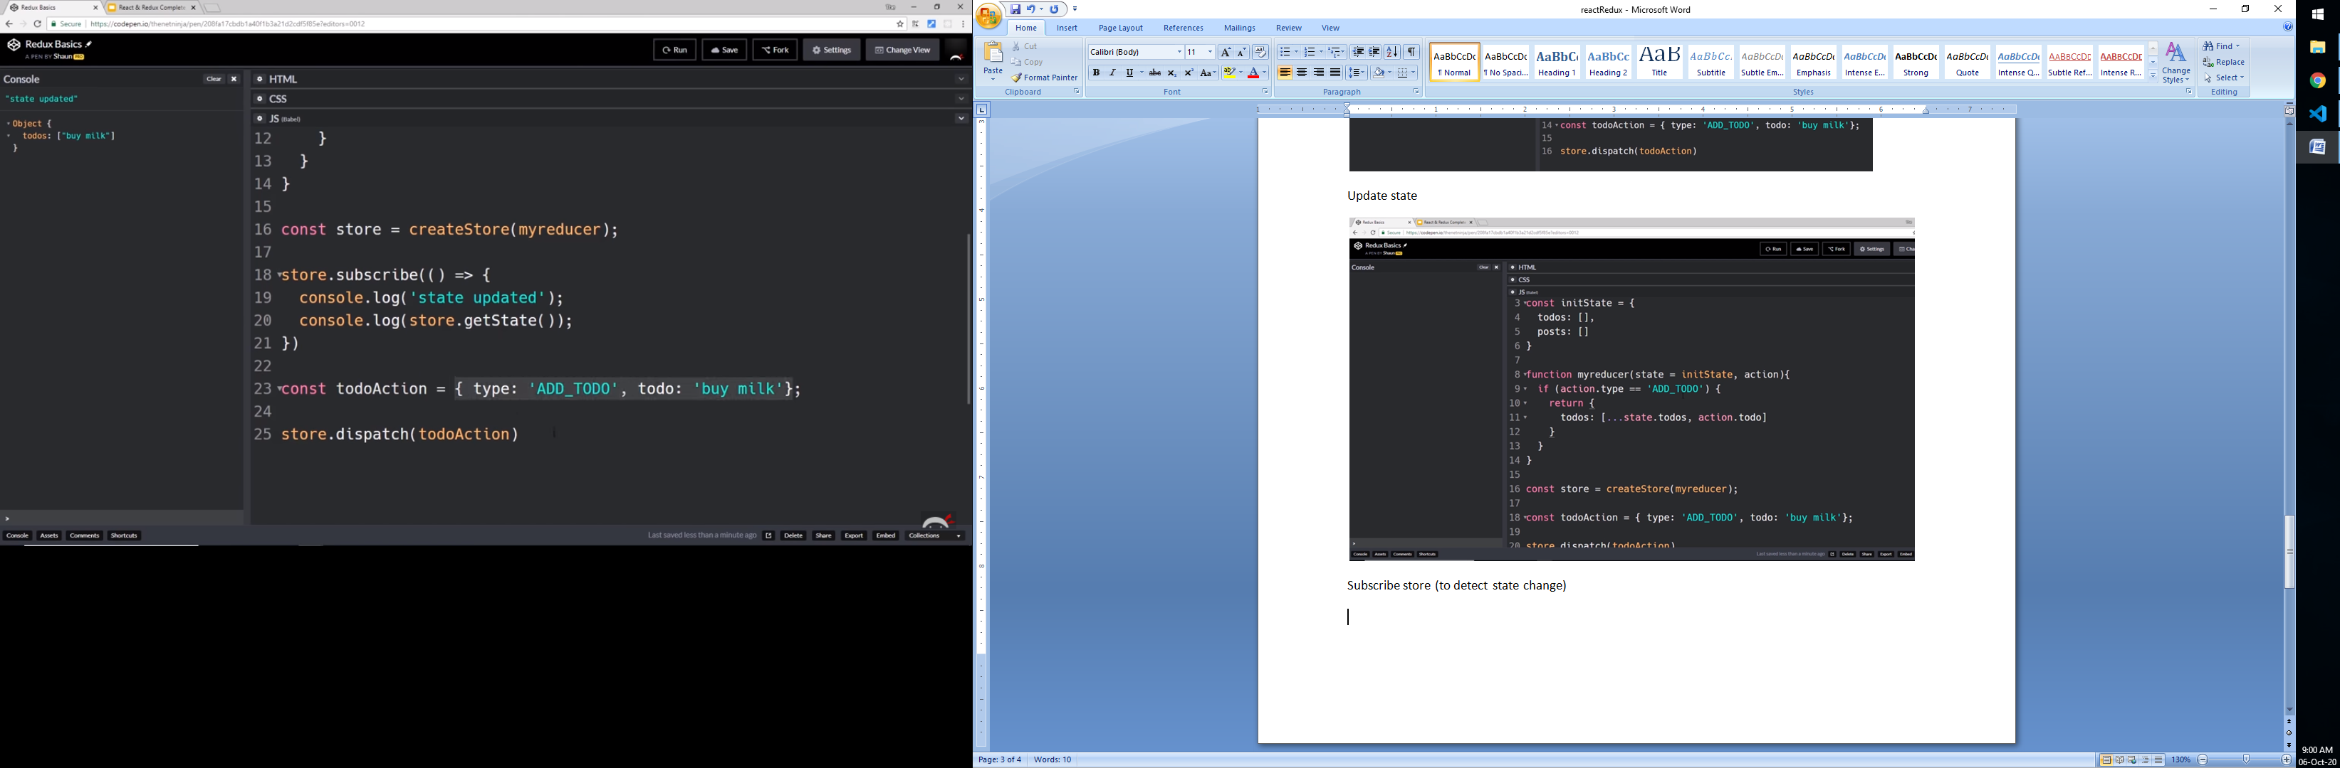

Above reducer overwrite other state. We can overcome this problem by using this approch

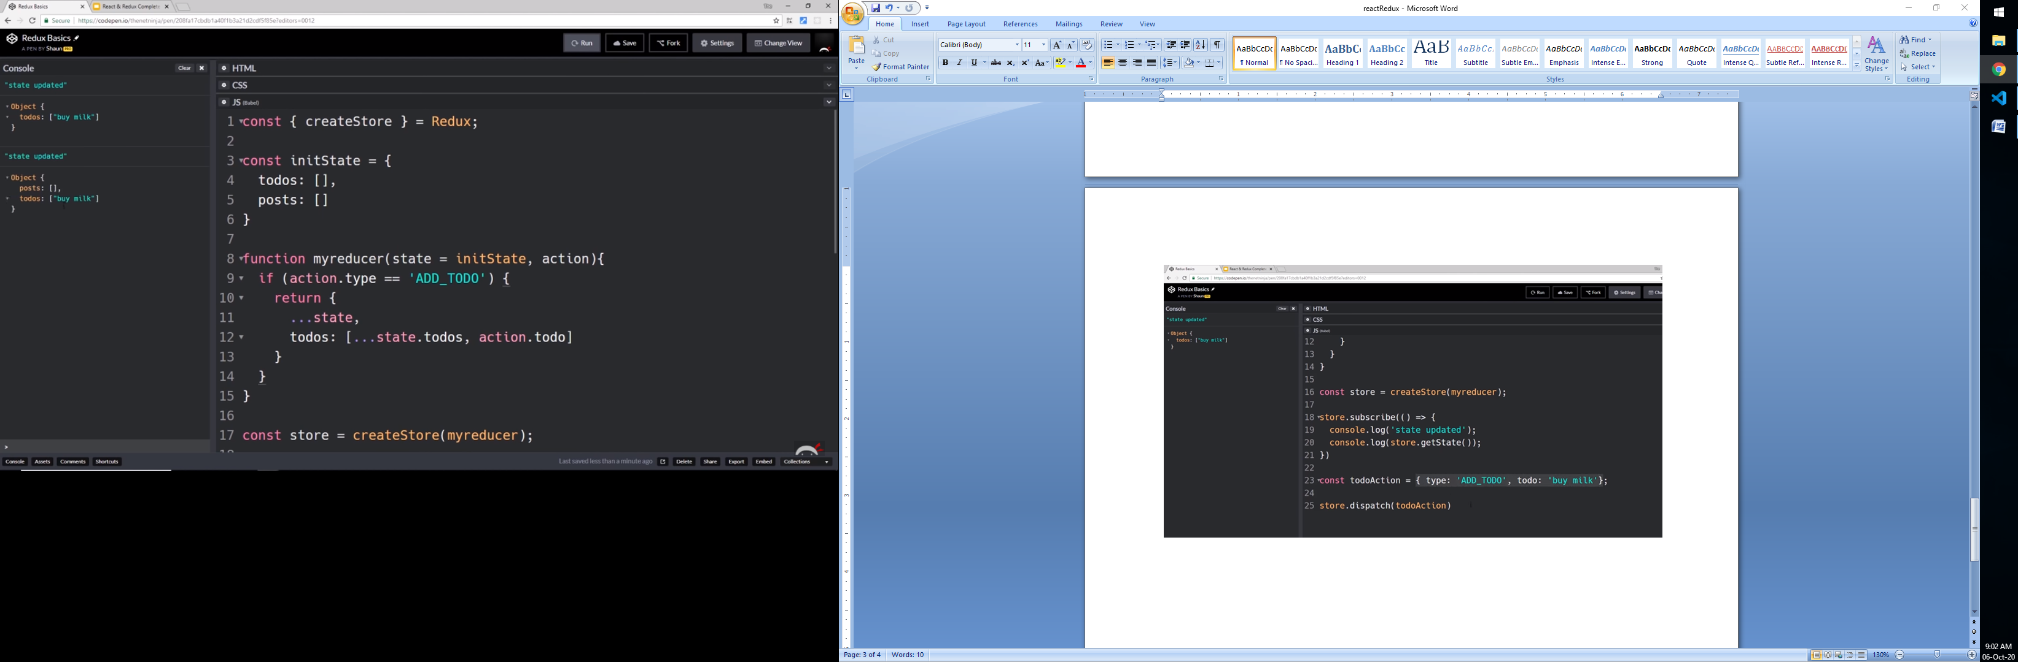

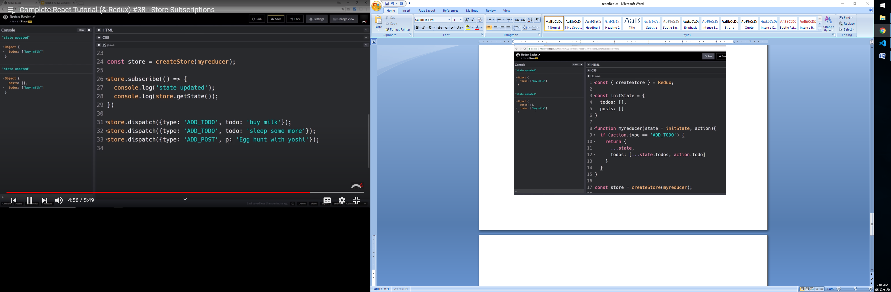

Npm install redux react-redux –save

Index.js

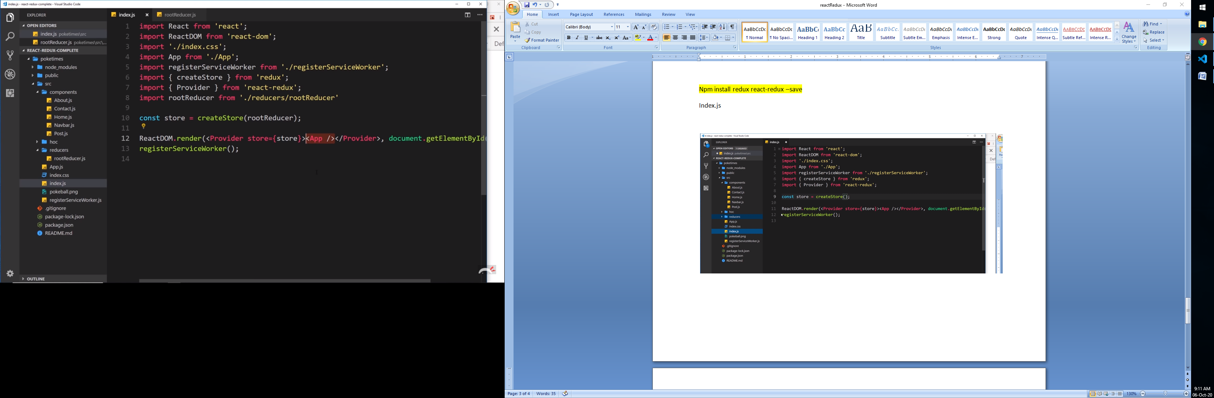

Create Reducer inside reducer folder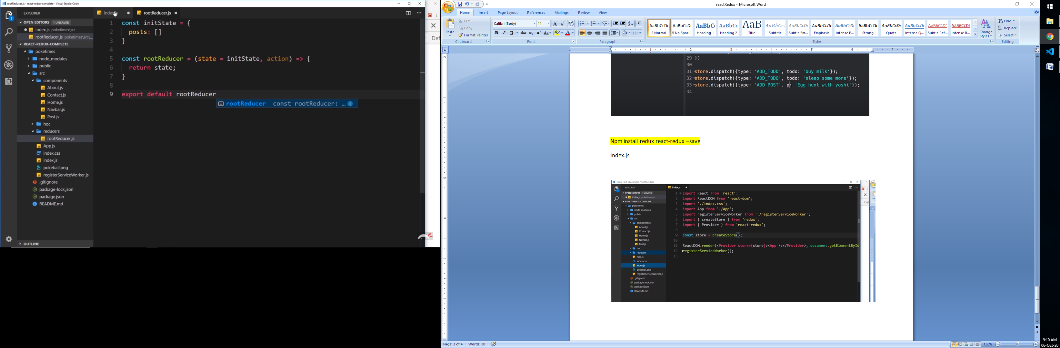

Add sum dummy data in reducer

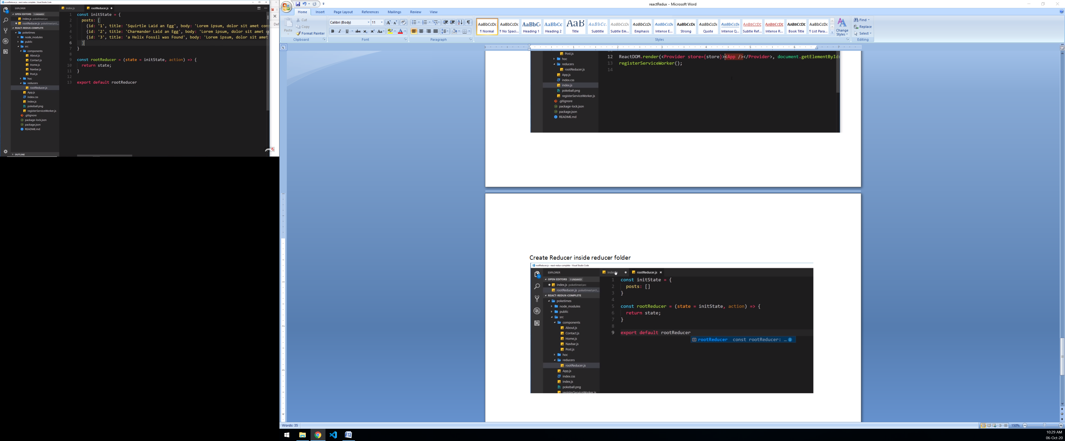

Subcribe store in component

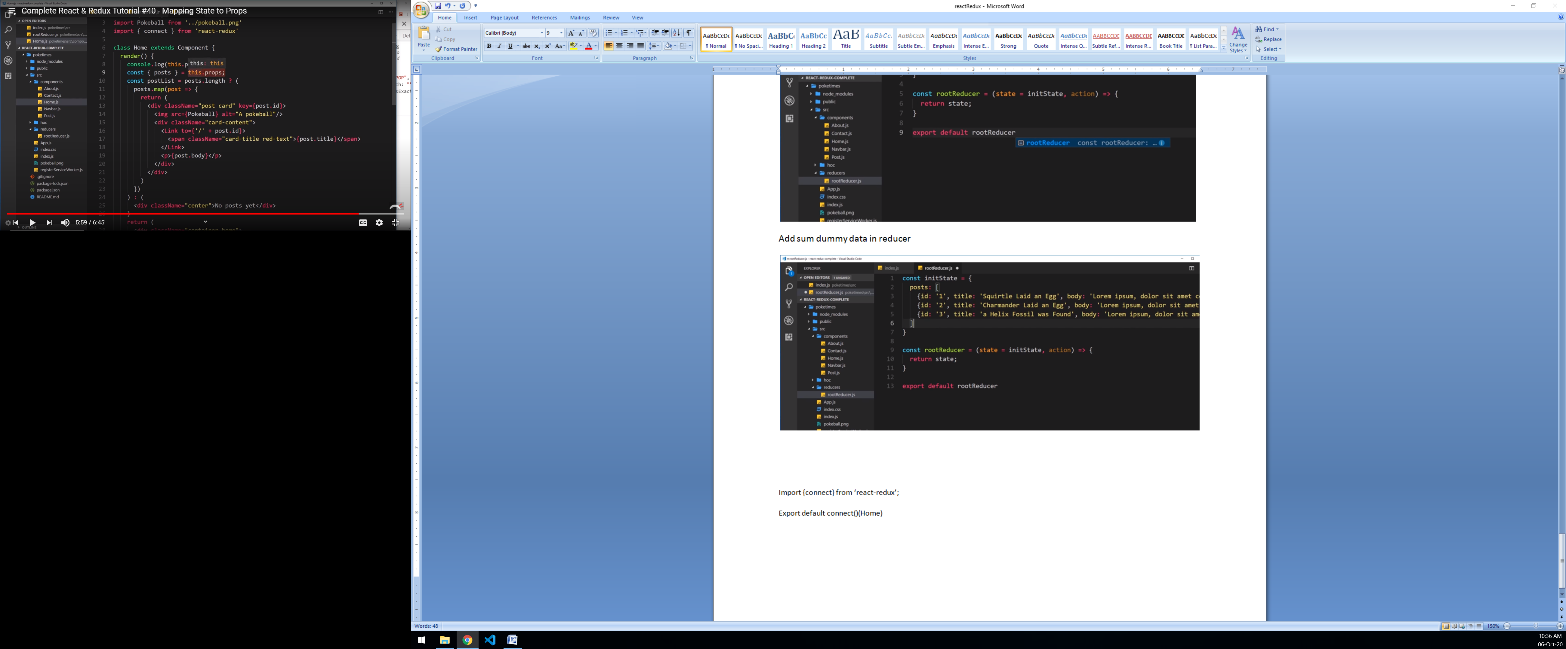

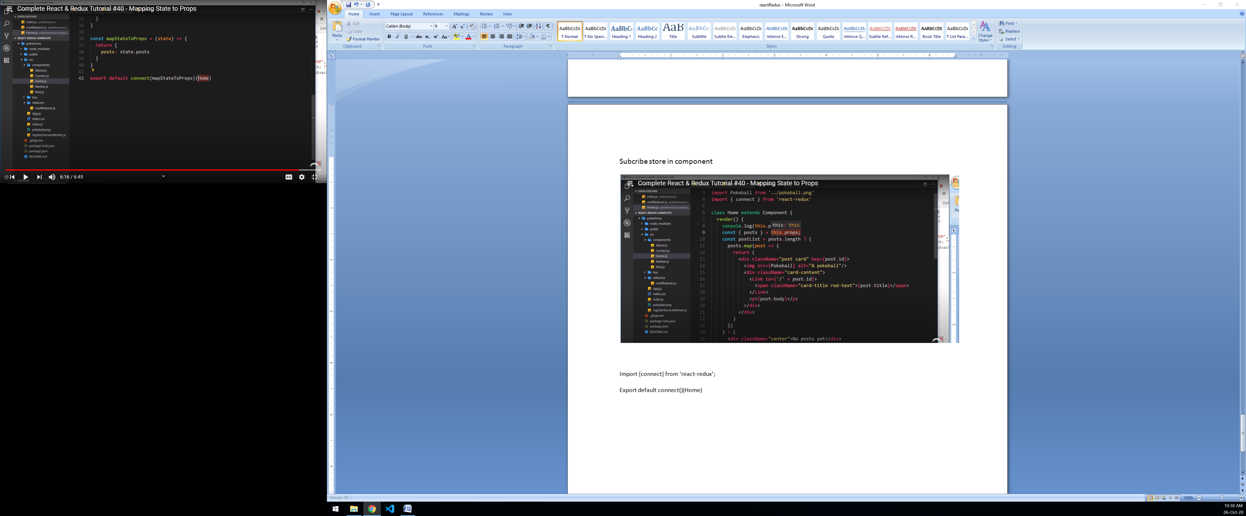

1)Import {connect} from ‘react-redux’;

2) create mapStateToProps function inside component. No state will use because it maps state of store into props

3) Convert component to HOC with connect. It glue the store with components

Export default connect(mapStateToProps)(Home)

Fetch single records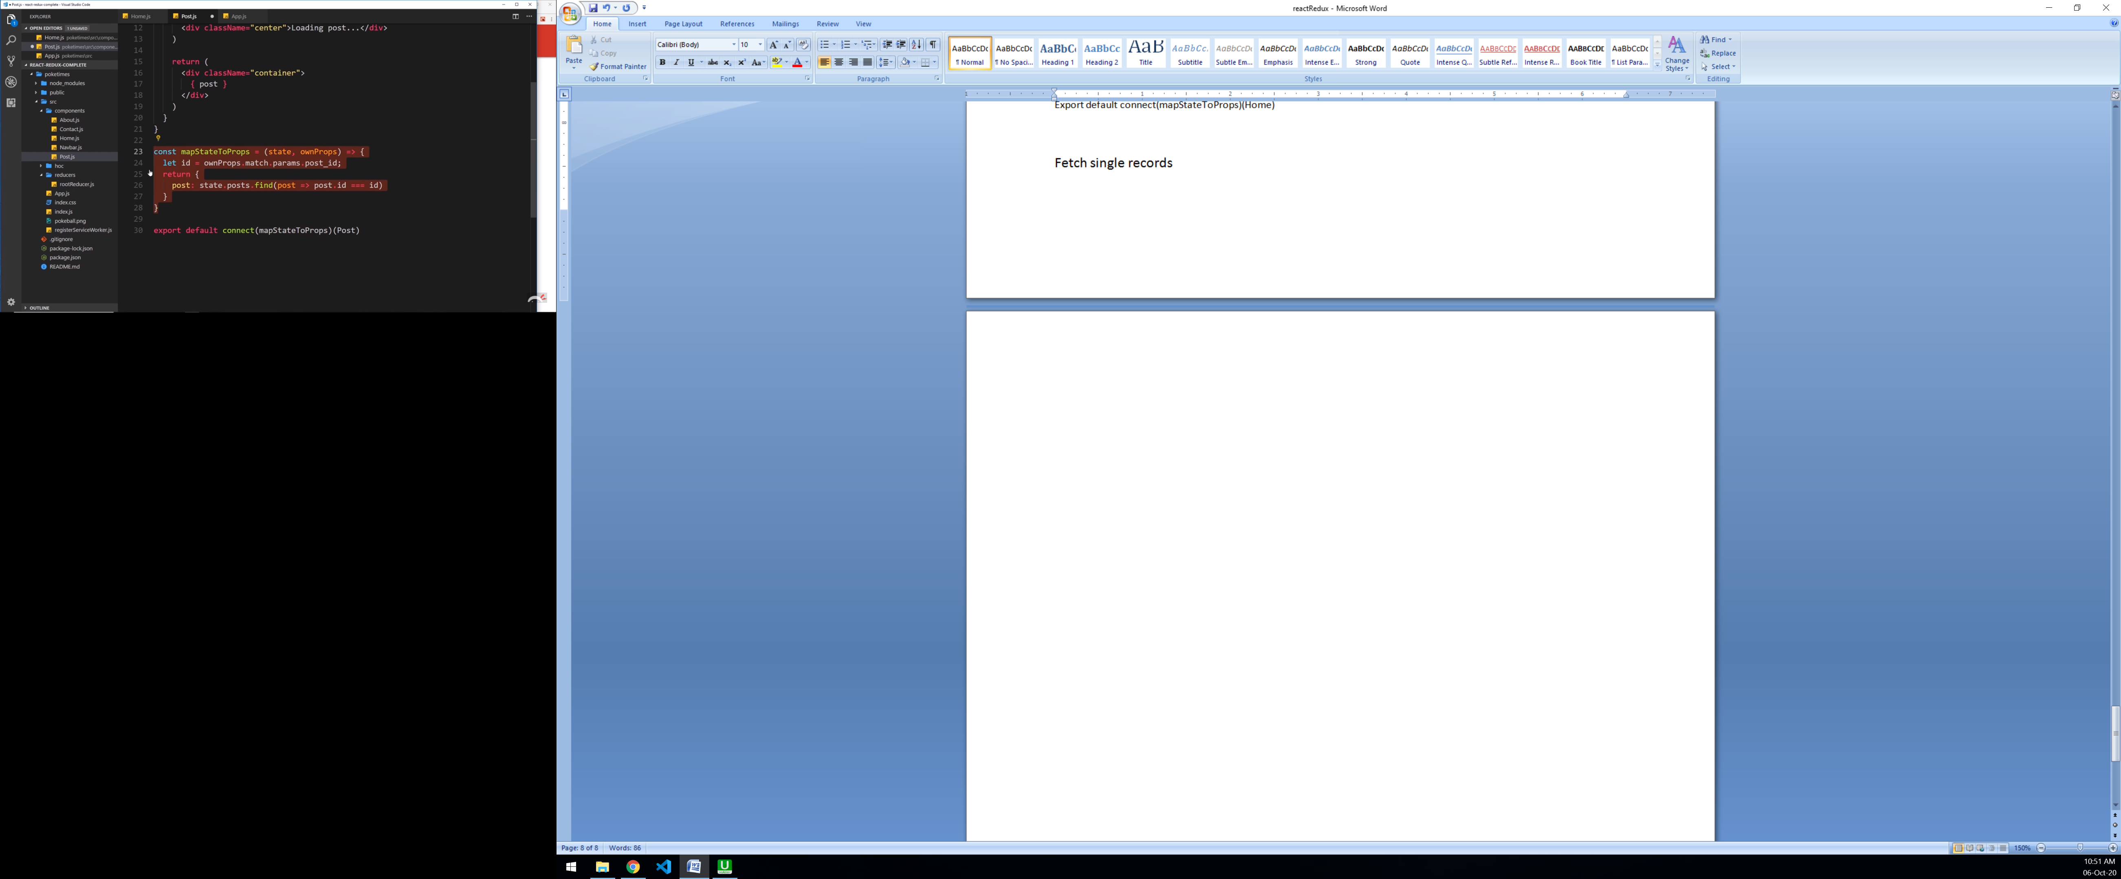

ownProps works like props of components

Dispatch action (Delete post)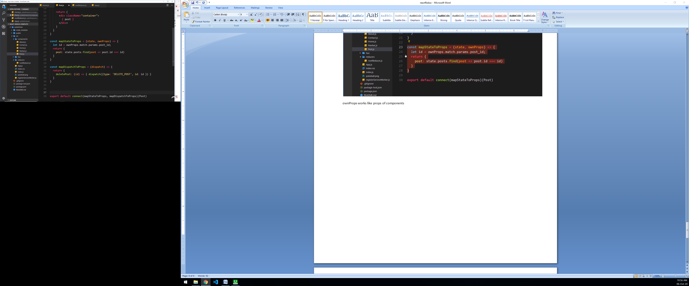

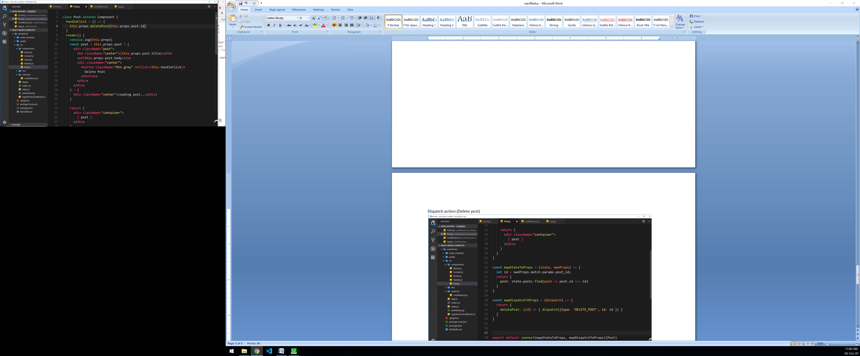

Update reducer

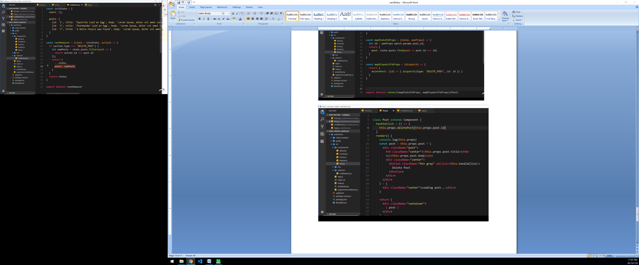

Redirect to home page after delete

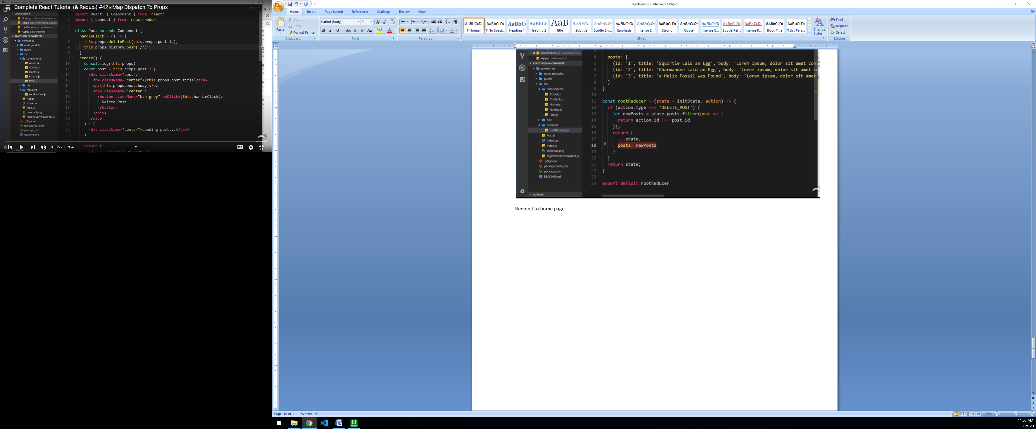

Separating Actions

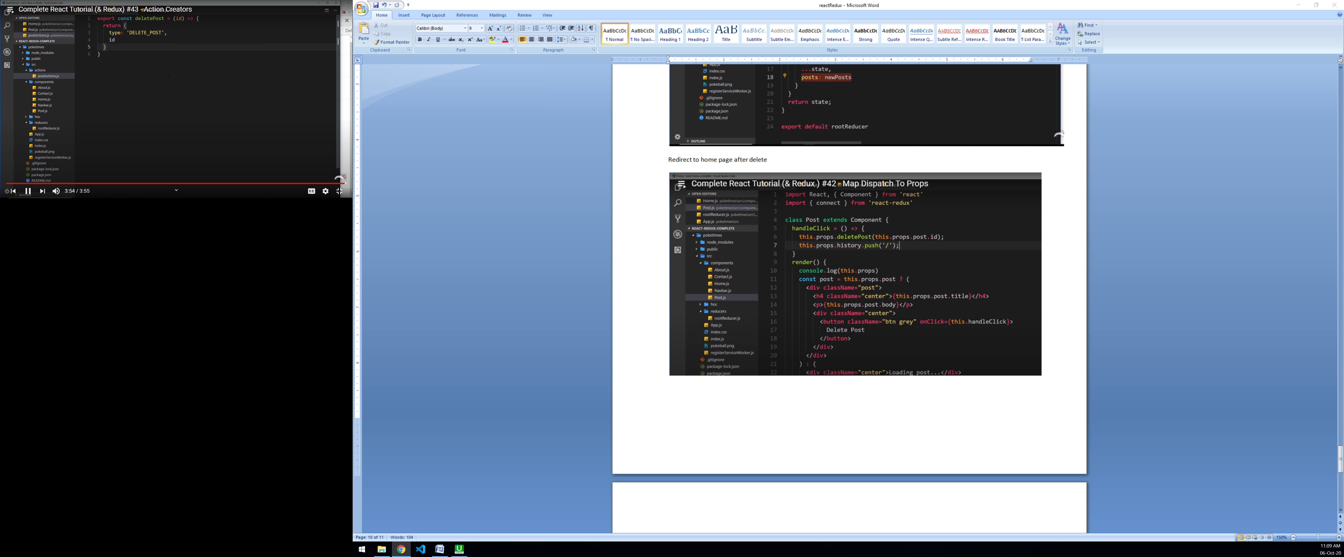

Import action

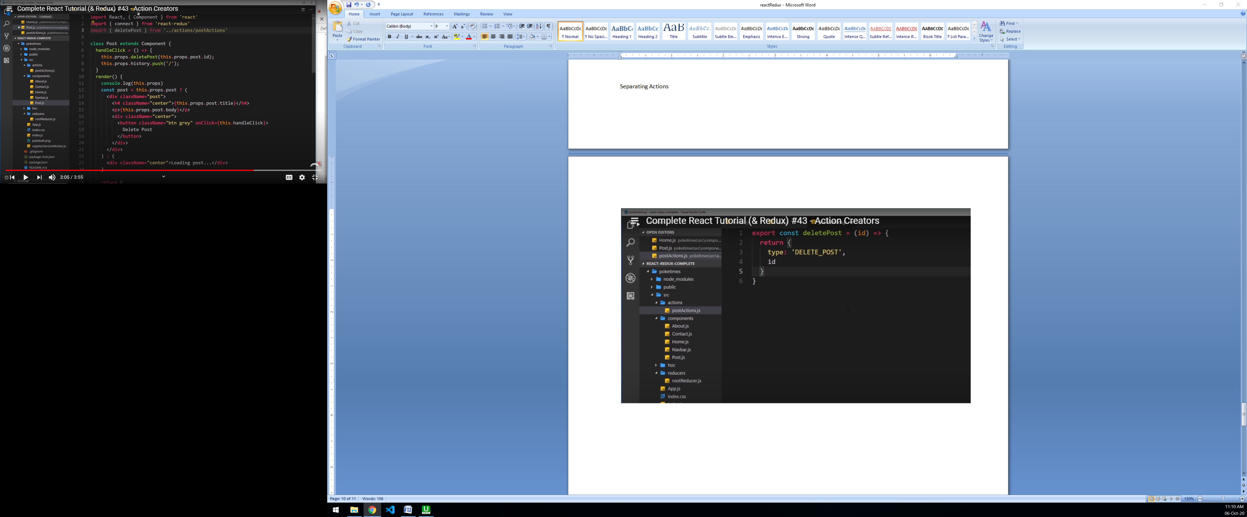

Used inside dispatch

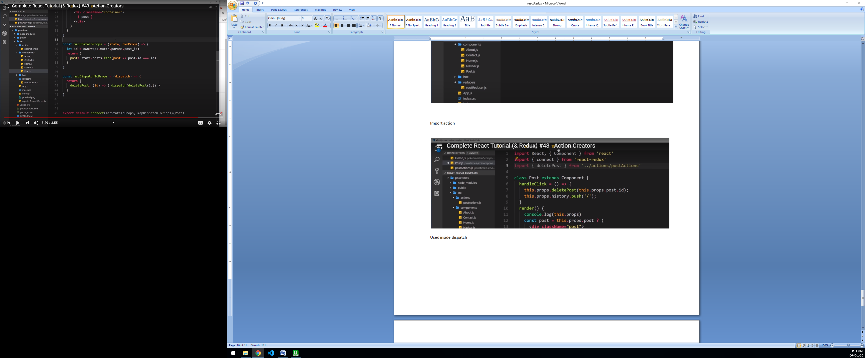

<https://github.com/tutorials-website/Redux-Tutorials-Code>